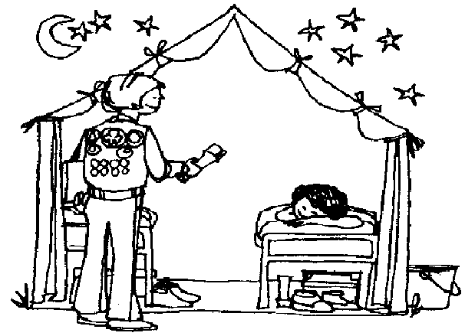
Govorni nastop – 5.r (marec 2020)
MY MAGIC/ DREAM TENT
- Opiši svoj sanjski/ magični šotor. Pomagaj si z naštetimi vprašanji:
What is it like? What colour is it? Is it big/ small/ medium sized? How high is it? What is it made of (material)?
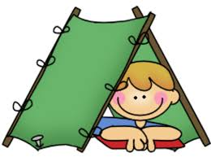
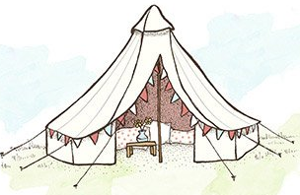
- Opiši notranjost:
What is in your tent? Where are the things? Has the tent got more parts or rooms? Is it special or magical in any way? Why is it special?
- Opiši kaj lahko tukaj počneš:
What can you do in the tent? How do you spend your day in the tent? Does anyone live here with you? Have you got any pets/ animals? Do you live here all the time? Do you come here only on special days?

