Najprej preveri nalogo 6B iz učbenika str. 83, ki si jo naredil(a) prejšnjo uro:

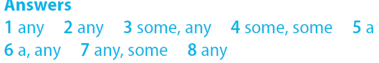

Nadaljuj z vajami za števne in neštevne samostalnike, a / an, some / any na povezavah:
https://www.englisch-hilfen.de/en/exercises/confusing_words/some_any.htm
https://www.ego4u.com/en/cram-up/vocabulary/some-any/exercises?02
https://www.liveworksheets.com/worksheets/en/English_as_a_Second_Language_(ESL)/There_is_-_there_are/There_is_-_There_are_%5E_a,_an,_some,_any_gy25424bs
https://www.grammar.cl/Games/Some_Any_A_An.htm
https://www.english-grammar.at/online_exercises/quantifiers/quantifiers1.htm

Naredi naloge v delovnem zvezku str. 53.

