7. razred, preverjanje 3
- Put the verbs in the Present Simple Tense.Postaviglagole v sedanjik Present Simple.

Hi! I'm Jenny. I'm a famous writer. Just kidding! But I really WANT__(want) to become a writer one day.
I ___love___ (love) reading detective stories and horror stories. My parents_don’t believe_ (not believe) I can become a writer one day. My mother __thinks_____ (think) that it __isn’t__ (not be) a real job and my father ___says______ (say) that writing _doesn’t bring___ (not bring) a lot of money. But I __don’t agree__ (not agree) with them. I____know_____ (know) that there are a lot of writers who are rich.

- Put the verbs in the Present Continuous Tense.Postaviglagole v sedanjik Present Continuous.

We _ARE DOING___ (do) English exercises right now.
We __are preparing_ (prepare) for the test.
We ___aren’t having__ (not have) History at the moment.
____Is____ Henry ____writing____ (write) in his notebook?
I __am looking______ (look) through the window.
Why __is___ Lara __standing___ (stand) at the bus station?
__Is____ she ____waiting___ (wait) for someone?

- Complete the text. Use the Present Continuous or the Present SimpleTense.Vstaviustrezensedanjik– Present Simple ali Present Continuous.

- Peter and Mary ____live____ (live) in Bristol. Peter ___works____ (work) in a car factory and Mary __is___ (be) a doctor. At the moment theyaren’t working______ (not work).
- They __are travelling___ (travel) on holiday. They ___are driving___ (drive) to Southport. They __go__ (go) thereevery summer.

c) My name _____is___ (be) Yoko. I ___come___ (come) from Japan. My parents and I ___live______(live) in Tokyo. My mother____is____ (be) a secretary but she __isn’t working______ (not work) at the moment.She _is taking_ (take) care of my little sister who is only three months old.I ___love____ (love) my sister, but I __don’t like__ (not like) her crying. Oh no! She ____is crying__ (cry) again!

- Put the sentences into thePast Simple Tense.Postavipovedi v preteklik Past Simple.Glej primer.

PRESENT SIMPLE | PAST SIMPLE
I swim I swimat our local swimming pool very often. | I swam at our local swimming pool very often.
There are many shops in our town. | There were many shops in our town.
We Wecan go to France by train. | We could go to France by train.
I do I don't visit my best friend every day. | I didn’t visit my best friend every day.
They see their mum through the window. | They saw their mum through the window.
I don't eat pizza very often. | I didn’t eat pizza very often.
We can't come to the party. | We couldn’t come to the party.
- Put the verbs in brackets intothe Past Continuous Tense.Postaviglagole v oklepajih v preteklik Past Continuous. Glej primer.

Last Friday my sister and I had a party at our house. We had the house all to ourselves because our parents were staying (stay) with grandma for the weekend. While they _were enjoying___(enjoy) their weekend in the country, we __were having__ (have) a great time with our friends. I _was__still__getting_ (get) the food ready when the first guests arrived.Toby was the DJ. He __was playing___ (play) music all evening.Tina _was making_ (make) fruit cocktails. They were delicious. While we __were dancing_ (dance) someone knocked on the door. It was our neighbours. We __were making__ (make) too much noise. I apologized and they said it was all right as long as we were a bit quieter.

- Put the verbs in brackets into Past SimpleorPast Continuous.Postaviglagole v Past Simple ali Past Continuous.

Last Saturday I __was waiting_ (wait) for my parents to come home in the evening .It _____was___ (be) late.I ___was sitting__ (sit) in front of TV and __eating___ (eat) dinner when suddenly the bell ___rang___ (ring). I __was_ (be) scared because I __was watching__ (watch) a horror movie. I __went__ (go) to the door. A dark figure ___was standing___ (stand) outside. I __ran___ (run) back into the living room and __called_____ (call) Mum and dad. While I __was dialling__ (dial), somebody suddenly ___knocked___ (knock) on the window. It ___was___ (be) my grandma who came to check if I was ok.
- Vocabulary. Label the pictures.Kajvidišnasliki? Poimenuj.
1 bridge, 2 forest, 3 car park, 4 castle, 5 church, 6 market, 7 factory

- Complete the sentences with the names of places or shops in a town.Dopolni.
1 café, 2 cinema, 3 hospital, 4 post office, 5 baker’s, 6 bank, 7 clothes shop, 8 newsagent’s
- Connect the words from the box with their Slovene translations.Poveži z ustreznimiprevodi.
hutchildhood Stone Agehuntergorge medievalgate crossroads
English | Slovene |  | English | Slovene
Stone Age | kamenadoba |  | hunter | lovec
hut | koča |  | gate | vrata
crossroads | križišče |  | medieval | srednjeveški
childhood | otroštvo |  | gorge | soteska

- Fill in the words from the box so that you get meaningful sentences.Smiselnodopolni z besedamiizokvirja.

matchessunscreen judgehaunts guideprisonfields notice board

We went down the Soča River on a raft with a local ___guide___.
Many years ago the Tower of London was a _____prison_____.
We use a lighter or _____matches_____ to make fire.
Farmers have large____fields____ where they grow food.
People say that the ghost of Anne Boleyn still _______haunts______ the Tower of London.
‘I didn’t kill him!’ said Billy, but the ____judge____ didn’t want to listen.
You should always put on _____sunscreen_____ when you spend a lot of time in the Sun.
Last week I put a message on the_____notice board______ at school.

- Asking the way. Complete the dialogue with the expressions from the box.Dopolni z besedamiizokvirja.
roundaboutright go along go straight on are there welcome past
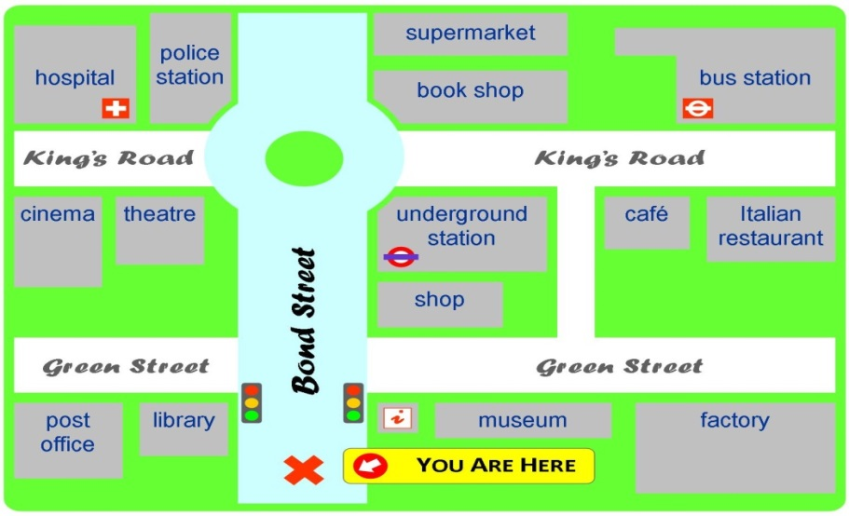
TOURIST:Excuse me, ___are there___any good restaurants around here?
WOMAN:Yes, I know a very good Italian restaurant and it is not far from here.___Go along_____ Bond Street. At the traffic lights ____go straight on_____ until you come to a ____roundabout____. Take the second exit at the roundabout. Go along King's road ,___past____ the underground station and a café. The restaurant is on your __right_____, next to the café.

TOURIST:Thank you very much!

WOMAN:You're___welcome____!

- Writing.Which of the following inventions is the most important for you? A mobile phone, television, CD player X-box or computer?Katera od zgorajomenjenihnaprav je zatenajpomembnejša?
Why? Write 50 to 60 words. Give at least two reasons for your choice and write three things that you can do with this invention.Zakaj? Napišivsajdvarazloga
Napiši tri stvari, kijihlahkopočneš s pomočjotenaprave.Primer rešitve:
I think that the most important invention of all is the mobile phone, especially the smart phone. It is small enough to put it in a pocket or in a bag and take it with you anywhere you want. With it you can get all kinds of information and be connected to the world. You can use it for phoning people, sending text messages or MMS-es, listening to music, or you can use it as a computer. It is really a very useful gadget.____________________________________________________________
- Read the text and decide whether the statements below are true, false or it doesn'tsay in the text.

Tom Barker was born thirty years ago in a small village on the south coast of England¹, but when he was ten years old his family moved to London because Tom's father got a good job in a bank². Last week Tom went back to the village³ where he spent the first ten years of his life. This is what he told us when we interviewed him:
»I could remember the village very well. When I was a child, there was a small village shop where you could buy everything you wanted. They sold fantastic sweets and cakes and fresh bread⁵. I went to the village school for five years. There were only thirty pupils in the school, so the classes were very small. At weekends, we took our bikes⁷ and went to the beach. We didn't stay at home very often because we didn't have a television in those days, but when the weather was cold, I often spent time at my friend's houses. Everybody in the village was very friendly.
But now, everything is different. When I came back last week, I couldn't find our house⁸. There isn't a village shop or a post office. Now there's a large supermarket and people go shopping there. There are new houses everywhere, but the village school is closed¹⁰. All the children go to school in the town a few miles away.
I was very sad¹¹ because the village isn't the way I remembered it. My old friends weren'tthere, and the new people weren't very friendly. «
 | T/F/DS
- Tom was born in a small village in Scotland. | F
- Tom's father worked in a bank. | T
- Tom went back to the village last year. | F
- There was a chemist's in the village. | DS
- The village shop sold bread. | T
- Tom's sister went to the village school. | DS
- Tom had a bike when he lived in the village. | T
- Tom visited his old house. | F
- There's a big car park at the supermarket. | DS
- Children don't go to school in the village now. | T
- Tom was very happy when he went to the village. | F

